Siege (2 players)
Introduction
Siege is a strategy type guessing game for two players. It is played on 2 rows by 5 columns of cards on which each player has a lord hidden underneath one of the cards. The location of the lord is concealed from the other player.

Objective
Find your opponent’s lord before they find yours.

Set Up
- There are 2 types of wall, Palisade Wall and Stone Wall. Palisade Walls have a max health of 3 whereas Stone Walls have a max health of 5
- Arrange the 5 Palisade Wall cards in a row (1 to 5 from left to right) and the 5 Stone Wall cards (6 to 10 from left to right) behind each Palisade. Palisade Walls are also referred to as Front Row while Stone Walls are also referred to as Back Row.
- Decide on which player starts first who will be referred as Player 1 while the other as Player 2.
- Both players take their turn hiding their Lord token under one of their Wall cards while the other player looks away.
- Both players each gets a deck which contains:
  - 1 Catapult card
  - 1 Ballista card
  - 1 Shield card
  - 3 Axe cards
  - 3 Sword cards
  - 3 Spear cards
  - 3 Bow cards
  - 3 Crossbow cards
  - 1 Repair card
  - 1 Rebuild card
- Both player shuffle their deck and draw 5 cards

Playing the Game
- During each player’s turn, the player can either:
  - Play an Armory card: The player chooses one card in their hand, discards it and then draws one card. The discarded card will have the following effects depending on its name:
    - Catapult: Deals 3 damage to any enemy wall
    - Ballista: Deals 1 damage each to 5 random enemy walls (Randomize a number from 1 to 10, 5 times, if the same position is rolled a second time, a free roll is given. However, if the wall in a rolled position is destroyed, there is no free roll)
    - Axe: Deals 2 damage to any one of the enemy walls in the front row
    - Sword: Deals 1 damage each to 3 enemy walls next to each other in the front row
    - Spear: Deals 1 damage each to any one of the enemy walls in the front row and the wall behind it
    - Bow: Deals 1 damage each to 3 enemy walls next to each other in the back row
    - Crossbow: Deals 2 damage to any one of the enemy walls in the back row
    - Shield: Blocks and ignores damage once to the player’s own wall except for Catapult and Ballista
    - Repair: Recover own wall’s health by 1 (Cannot be used on wall with full health)
    - Rebuild: Rebuilds a destroyed wall with 1 health
If a card that targets a specific row has no wall on the selected column, the player can target the wall on another row of the same column. Each player can only discard 1 card per turn.
  - Call Attack: The player selects one of the wall numbers of the other player and deals 1 damage to it. (If there is a Palisade Wall card in front of the Stone Wall card on the same column, the player can only call to attack the Palisade Wall.) If the HP of the wall reaches 0, it is destroyed and removed.
- If any wall of the opposing player is destroyed, check whether the other player’s lord is under the wall. If the lord is found, the current player taking their turn wins the game, if not, the player must end their turn and the other player starts their turn.

Gameflow Chart
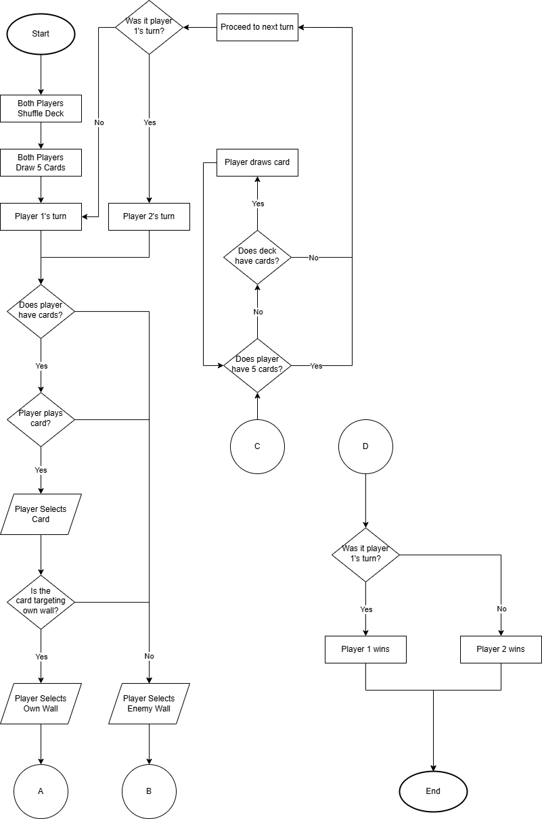
General Gameplay Flowchart
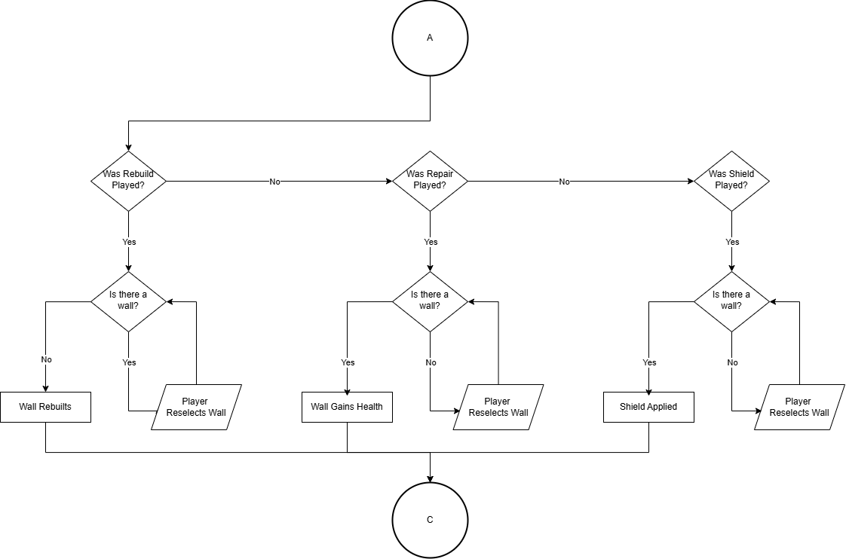
Support Flowchart
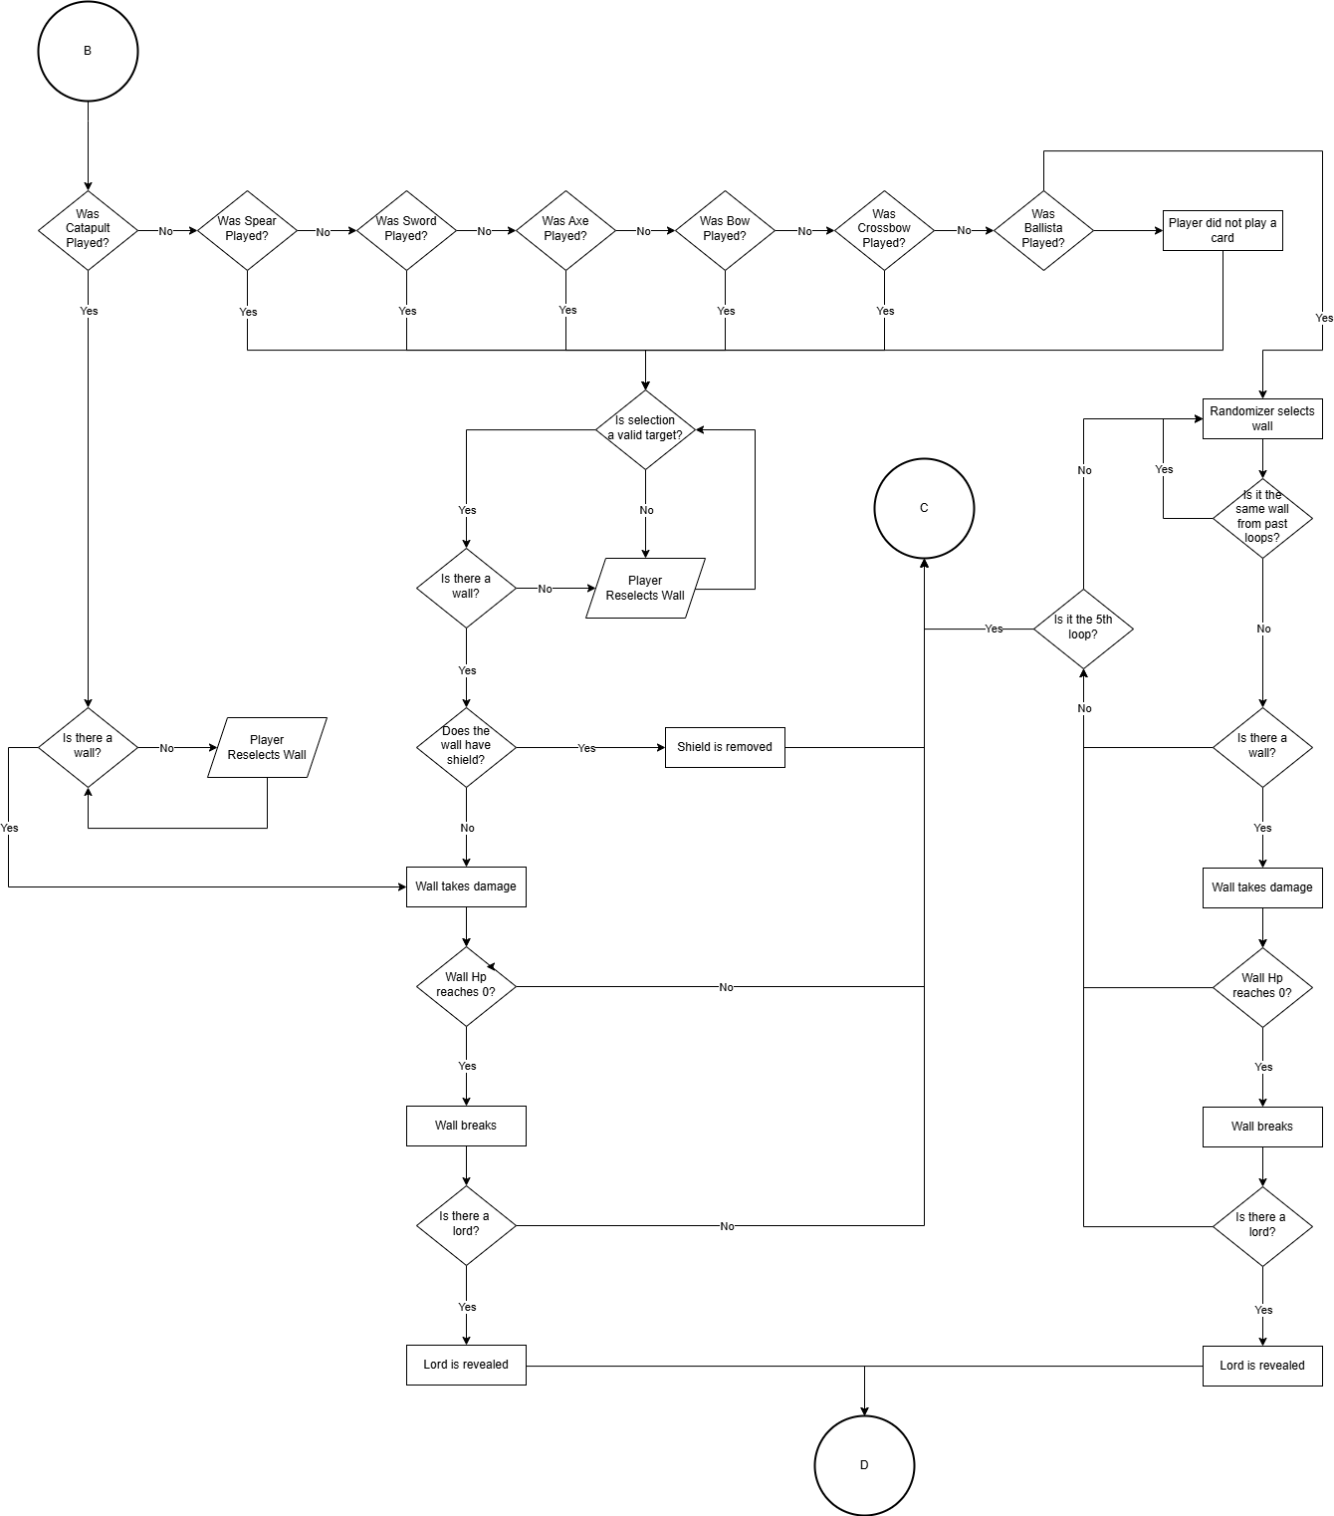
Attack Flowchart
UML Diagram
